Department of Computer Science had organized a “One day Webinar on “"AUTOMATION IS EVERYWHERE: TOWARDS BUILDING A SAFE AND ROBUST SOFTWARE PARADIGM" on January 11, 2022 at 5:00 PM in collaboration with IQAC, Asutosh College, and IEEE Computer Society, Kolkata section and IEEE Young Professionals, Kolkata section. The speaker of the session was Dr. Rajdeep Mukherjee, Applied Scientist at Amazon, USA. Dr. Mukherjee is Alumni of the Department of Computer Science, Asutosh College. After completing his graduation from Asutosh College, he did PG-B.Tech and M.Tech in Computer Science and Engineering from Rajabazar Science College, the University of Calcutta, and Indian Institute of Technology, Kharagpur respectively. He then did his Ph.D. from Oxford University, UK.
The entire recording of the Webinar is available on our college’s official YouTube channel. Here follows the link:
https://youtube.com/watch?v=hmKh65AoDoE&feature=share

Some images of the programme
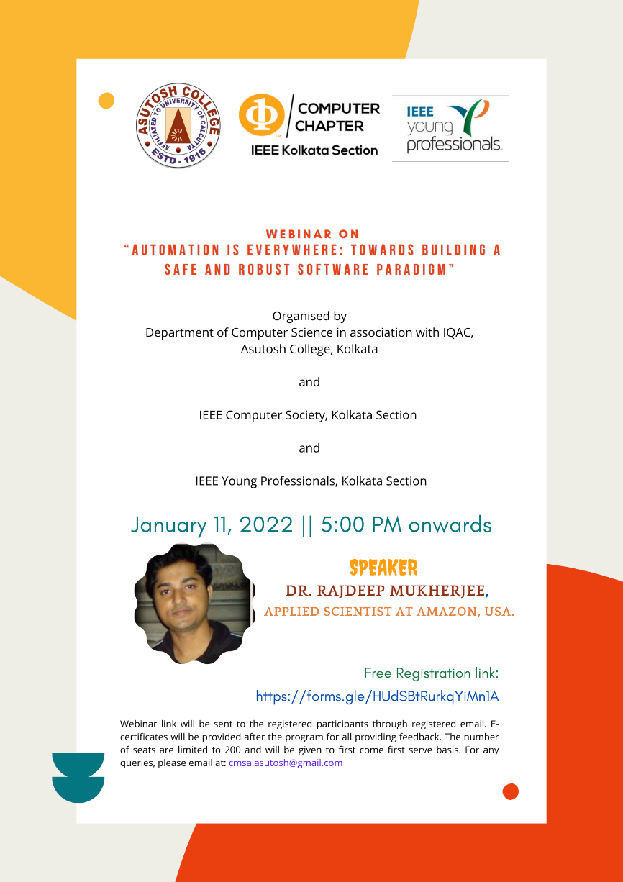
Poster
